Programming Assignment #1

(for Ch 2)

- Download the Dev-C++ compiler from http://sourceforge.net/projects/orwelldevcpp
- Install the Dev-C++ compiler on your computer.
- Run the Dev-C++ compiler.

Problem Description

Write a program to convert a temperature in degrees Fahrenheit degrees Celsius.

DATA REQUIREMENTS

Program Input
int Fahrenheit /* temperature in degrees Fahrenheit */

Program Output
double Celsius /* temperature in degrees Celsius */

Relevant Formula

Celsius = 5/9 (Fahrenheit - 32)

Hint: Be careful when int / int, see page 77 for type cast.

Sample Run

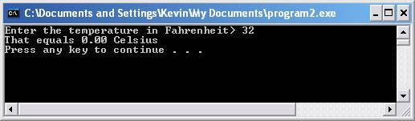

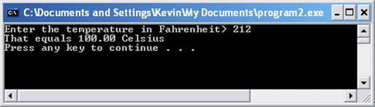

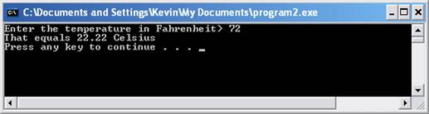

Problem Requirement
a) You must create a file and save it as Program1.c file.
b) The temperature in Celsius must be in 2 decimal places.
c) Your program should run correctly with the same inputs and outputs as given in the sample run.

